Agenda Item : 2/13

= application site



74 Whittington Way, Pinner | P/0073/18

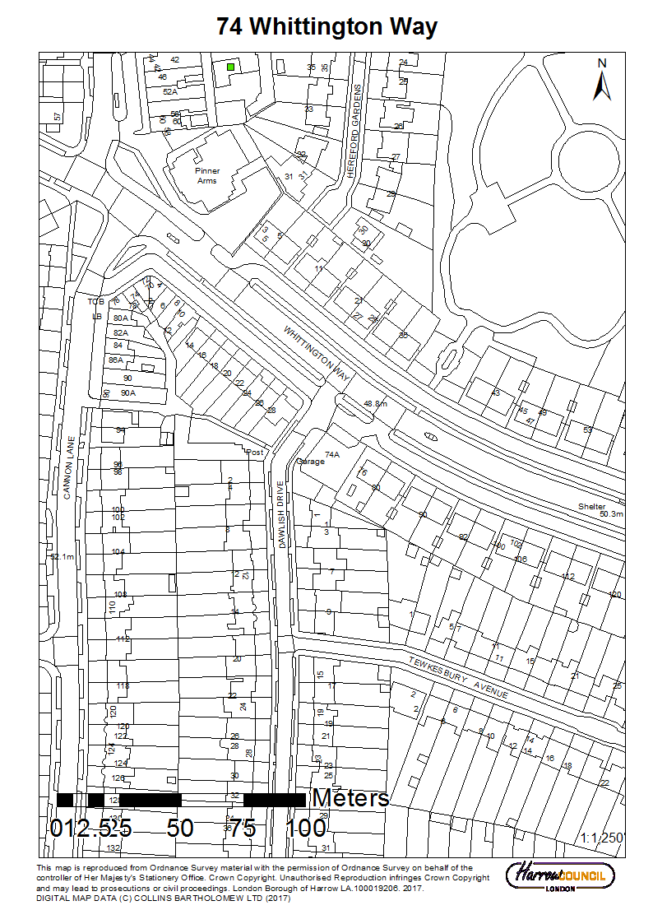

74 Whittington Way, Pinner | P/0073/18

LONDON BOROUGH OF HARROW

PLANNING COMMITTEE

APPLICATION NUMBER: | P/0073/18
VALIDATE DATE: | 30/01/2018
LOCATION: | 74 WHITTINGTON WAY, PINNER
WARD: | PINNER SOUTH
POSTCODE: | HA5 5JX
APPLICANT: | PINNER REAL ESTATE AND TESCO STORES LTD
AGENT: | RPS CGMS
CASE OFFICER: | TENDAI MUTASA
EXPIRY DATE: | 27/03/2018 (EXTENDED)
PURPOSE OF REPORT/PROPOSAL

The purpose of this report is to set out the Officer recommendations to the Planning Committee regarding an application for planning permission relating to the following proposal.

Change of use from MoT testing centre and car showroom (use class Sui Generis) to retail (use class A1) at ground floor level; associated parking and access; external alterations.

The Planning Committee is asked to:

RECOMMENDATION A

- agree the reasons for approval as set out in this report, and

- grant planning permission subject to authority being delegated to the Divisional Director of Regeneration, Enterprise and Planning in consultation with the Director of Legal and Governance Services for the completion of the Section 106 legal agreement and other enabling legislation and issue of the planning permission and subject to minor amendments to the conditions (set out in Appendix 1 of this report) or the legal agreement. The Section 106 Agreement Heads of Terms would cover the following matters:

  - The developer/applicant should enter into a s278 agreement with the Highways Department for the access into the parking area to be limited to one way in and one way out to minimise conflicting manoeuvres, and for the existing vehicular access onto Dawlish Drive to be reduced in size.
  - Legal Fees: Payment of Harrow Council’s reasonable costs in the preparation of the legal agreement.
  - Planning Administration Fee: Payment of £500 administration fee for the monitoring and compliance of the legal agreement

REASON FOR THE RECOMMENDATIONS

The proposed development of the site would return a vacant commercial unit back into productive and economical use, create local jobs, increase shopping convenience to local residents and is considered to result in an efficient and effective use of the site. Accordingly, the proposed change of use and general upgrading of the site is acceptable, subject to compliance with the relevant National, London and Local Development plan policies which seek to achieve a high standard of design, be consistent with existing land uses, protect the amenity of neighbouring occupiers and provide local employment in accordance with Section 1, Building a strong, competitive economy of the National Planning Policy Framework; Policies 3.16 and 3.17 of The London Plan (2016), Policy DM1 of the DMP (2013).

The decision to GRANT planning permission has been taken having regard to the National Planning Policy Framework 2012, the policies and proposals in The London Plan 2016, the Harrow Core Strategy 2012, Development Plan Documents: Harrow and Wealdstone Area Action Plan and Development Management Policies Local Plan 2013, and to all relevant material considerations, and any comments received in response to publicity and consultation.

RECOMMENDATION B

That if, by 24th June 2018 or such extended period as may be agreed in writing by the Divisional Director of Planning, the section 106 Planning Obligation is not completed, then delegate the decision to the Divisional Director of Planning to REFUSE planning permission for the appropriate reason.

The proposed development, in the absence of a legal agreement for the developer/applicant to enter into a s278 agreement with the Highways Department to undertake physical alterations to the access to parking areas to limit this into a one way system to mitigate any conflicting manoeuvres which would be to the detrimental of highways safety, would fail to comply with the requirements of policies 7.4.B and 7.5 of The London Plan 2016 and policy CS1.J of the Harrow Core Strategy 2012 and Policies DM1 and DM42 of the Harrow Development Management Policies Local Plan2013 and would therefore be unacceptable.

INFORMATION

This application is reported to planning committee due to the public interest received under part 1, Proviso E of the scheme of delegation dated 29th May 2013.

Statutory Return Type: |  | Minor
Council Interest: |  | None
GLA Community Infrastructure Levy (CIL) Contribution (provisional): £11,725.00
Local CIL requirement: £33,500.00
HUMAN RIGHTS ACT

The provisions of the Human Rights Act 1998 have been taken into account in the processing of the application and the preparation of this report.

EQUALITIES

In determining this planning application the Council has regard to its equalities obligations including its obligations under section 149 of the Equality Act 2010.

For the purposes of this application there are no adverse equalities issues.

S17 CRIME & DISORDER ACT

Policies 7.3.B and 7.13.B of The London Plan and Policy DM1 of the Development Management Polices Local Plan require all new developments to have regard to safety and the measures to reduce crime in the design of development proposal. It is considered that the development does not adversely affect crime risk.

LOCAL GOVERNMENT (ACCESS TO INFORMATION) ACT 1985
BACKGROUND PAPERS USED IN PREPARING THIS REPORT:

- Planning Application
- Statutory Register of Planning Decisions
- Correspondence with Adjoining Occupiers
- Correspondence with Statutory Bodies
- Correspondence with other Council Departments
- Nation Planning Policy Framework
- London Plan
- Local Plan - Core Strategy, Development Management Policies, SPGs
- Other relevant guidance

LIST OF ENCLOSURES / APPENDICES:

Officer Report:
Part 1: Planning Application Fact Sheet
Part 2: Officer Assessment
Appendix 1 – Conditions and Informatives
Appendix 2 – Site Plan
Appendix 3 – Site Photographs
Appendix 4 – Plans and Elevations

OFFICER REPORT

PART 1: Planning Application Fact Sheet

The Site

Address | 74 Whittington Way, Pinner
Applicant | Pinner Real Estate and Tesco Stores Ltd
Ward | Pinner South
Local Plan allocation | N/A
Conservation Area | N/A
Listed Building | N/A
Setting of Listed Building | N/A
Building of Local Interest | N/A
Tree Preservation Order | None
Other | N/A

Non-residential Uses

Existing Use(s) | Existing Use / Operator | Car Sales/MOT (Vacant)
Existing Use(s) | Existing Use Class(es) sqm | Use Class Sui Generis/B2
Proposed Use(s) | Proposed Use / Operator | Retail
Proposed Use(s) | Proposed Use Class(es) sqm | Use Class A1
Employment | Existing number of jobs | None – Vacant Site
Employment | Proposed number of jobs | 20 (some during the construction phase)

Transportation

Car parking | No. Existing Car Parking spaces | Unknown – approx. 4
Car parking | No. Proposed Car Parking spaces | 4
Car parking | Proposed Parking Ratio | 1 per 84 sqm
Cycle Parking | No. Existing Cycle Parking spaces | 8
Cycle Parking | No. Proposed Cycle Parking spaces | Conditioned
Cycle Parking | Cycle Parking Ratio | 1 per 42 sqm
Public Transport | PTAL Rating | 2
Public Transport | Closest Rail Station / Distance (m) | Pinner Station (1300m)
Public Transport | Bus Routes | H11 & H12 (60M)
Parking Controls | Controlled Parking Zone? | NO
Parking Controls | CPZ Hours | NO
Parking Controls | Previous CPZ Consultation (if not in a CPZ) | N/A
Parking Controls | Other on-street controls | Double yellow lines
Parking Stress | Area/streets of parking stress survey | All streets within 200m
Parking Stress | Dates/times of parking stress survey | Friday 1st & Saturday 2nd December 17. 8am-8pm & 9am – 5pm
Parking Stress | Summary of results of survey | 47% occupancy (average)  Minimum 110 spaces available at busiest time.
Refuse/Recycling Collection | Summary of proposed refuse/recycling strategy | As existing and Conditioned

Sustainability / Energy

BREEAM Rating | N/A
Development complies with Part L 2013? | Yes
Renewable Energy Source / % | N/A

PART 2: Assessment

- SITE DESCRIPTION

1.1 The application site occupies a corner plot at the junction with Whittington Way and Dawlish Drive.

1.2 The site comprises a two storey 1930’s style garage building with a flat roof and gabled roof rear projection. The rear projection forms the common boundary between the garage site and neighbouring maisonettes at no. 76 and 78 Whittington Way.

1.3 The premises were originally used as a petrol filling station. In recent years it was used as car sales with MoT servicing at the rear. The site is now vacant.

1.4 The existing premises consist of hardstanding to the front with an existing vehicular access from Dawlish Drive. There is a further existing vehicular access on the bend of Dawlish Drive which served the rear of the premises

1.5 The surrounding area predominately consists of residential dwellinghouses with 1930’s metroland properties on Dawlish Drive to the west and local authority maisonettes on Whittington Way.

1.6 The site is close to a local shopping parade located on the corner of Whittington Way and Cannon Lane. This is designated as a neighbourhood parade in the Local Development Plan.

- PROPOSAL

2.1 Change of use from MoT testing centre and car showroom (use class Sui Generis) to a 335m2 retail (use class A1) at ground floor level; associated parking and access; external alterations.

2.2 Cycle and bin storage have not been indicated on plans.

2.3 4 spaces for car parking would be provided to the front of the proposed development.

- RELEVANT PLANNING HISTORY

3.1 A summary of the relevant planning application history is set out in the table below:

Ref no. | Description | Status and date of decision
P/1430/17 | Variation to Condition 2 (Approved plans) to planning permission P/5189/16 dated 16/2/17 to allow amendment to the number of units from 6 x 1 bed and 3 x 2 bed flats to 3 x 1 bed and 6 x 2 bed flats and amendments to footprint and design of the proposed building (amended description) | Granted; 26/05/2017
P/4223/17/PRIOR | Conversion of Offices (Class B1a) to 4 Self-Contained Flats (Class C3) (PRIOR APPROVAL OF TRANSPORT & HIGHWAYS IMPACTS OF THE DEVELOPMENT, AND OF CONTAMINATION RISKS AND FLOODING RISKS ON THE SITE, AND IMPACTS OF NOISE FROM COMMERCIAL PREMISES ON THE INTENDED OCCUPIERS) | Granted; 09/11/2017
P/5189/16 | Redevelopment to provide a three storey building accommodating nine flats; amenity Space; parking; cycle and bin stores | Granted;15/02/2017
LBH/16179 | Roofing Over Rear Yard and Workshop | Granted; 05/02/1981
WEST/254/CLE | Certificate of Lawful Existing:  Use for Petrol Sales and Vehicle Repairs | Granted; 11/12/1996
WEST/571/00 | Certificate of Lawful Existing:  Use for MoT Testing | Granted; 05/07/2000

- CONSULTATION

4.1 A total of 8 consultation letters were sent to neighbouring properties regarding this application.

4.2 The overall public consultation period expired on 28th February 2018.

4.3 Adjoining Properties

Number of letters sent and site notice | 8
Number of Responses Received | 65 and a petition signed by 368 people
Number in Support | 0
Number of Objections | 65
Number of other Representations (neither objecting or supporting) | Petition with signatures

4.4 65 objections and a petition were received from adjoining residents.

4.5 A summary of the responses received along with the Officer comments are set out below: A number of the objections are the same.

Comment Objecting to the Proposal | Summary of Comments | Officer Comments
Loss Of Business to existing retails shops | The change of use of the garage would result in loss of business to existing shops at the nearby shopping parade which adequately serves the local residents. Especially being a Tesco store | The principle of the development is addressed in section 6.2 of the report
Suitability of site for retail use. | This site is not suitable for a store rather a community centre. This scheme will degrade the area. | Noted, character assessment is covered in section 6.7 of the report. Further the Council will only assess an application which has been submitted
Noise and fumes from fridges and delivery vehicles. Anti-social behaviour. The opening hours are not suitable | The proposals would bring noise nuisance. The opening hours are not suitable | The impacts of the proposals on neighbour amenity have been addressed in the report in section 6.5 and appropriate conditions have been attached to mitigate this. There is no evidence suggesting that Tesco stores bring about anti-social behaviour. Opening hours have been conditioned
Deliveries | Delivery vehicles will cause obstructions as area has no sufficient space | A condition for a travel plan and construction management plan has been attached
Invasion of privacy | Windows of the store will cause invasion of privacy to neighbouring properties | The store will be located at ground floor level hence there would be no loss of privacy issues.
Highways and Parking | Concerns regarding the increased parking problems in the area due to the new retail unit.  Potential danger to children crossing the street due to increased traffic.  No Cycle storage  Concerns in relation to parking spaces and impact on surrounding streets | These issues are covered in section 6.7 of the report
Food and Health | Food and waste will bring rats in the area which will in turn go into residents houses | This will be an issue for separate legislation and as such is not a material planning consideration
Waste Collection | Insufficient details have been provided for waste collection | A condition has been attached to this permission for details to be submitted to the local authority for consideration
Consultation | Only two addresses were consulted | The requirements only allow for adjacent properties to be notified of the application. A total of 8 neighbouring addresses were consulted
Contaminated site | No mention of pollutants on site | This has been addressed in section 6.9 of the report
Traffic study | Has a traffic study been carried for this site? | This has been carried out and has been addressed in section 6.7 of the report

4.6 Statutory and Non Statutory Consultation

4.7 The following consultations have been undertaken:

LBH Highways
LBH Waste Officer
LBH Drainage
Pinner Association

4.8 Internal & External Consultation

4.9 A summary of the consultation responses received along with the Officer comments are set out in the Table below.

Consultee | Summary of Comments | Officer Comments
Pinner Association | No comments received | Noted
LBH Drainage | No objections | Noted
LBH Environmental Health | Noise from additional mechanical plant is shown to be acceptable.  However, deliveries could cause problems as the report concludes- Therefore I would recommend to limit deliveries accordingly | Noted
LBH Highways | Comments received suggesting conditions relating to construction method statement, travel plan and S106 relating to access to site. | Noted, however it is considered that a CMP is not necessary in this instance as no construction is taking place.

- POLICIES

5.1 Section 38(6) of the Planning and Compulsory Purchase Act 2004 requires that:

‘If regard is to be had to the Development Plan for the purpose of any determination to be made under the Planning Acts, the determination must be made in accordance with the Plan unless material considerations indicate otherwise.’

5.2 In this instance, the Development Plan comprises The London Plan 2016, The Harrow Core Strategy 2012 [CS], Harrow and Wealdstone Area Action Plan (AAP) 2013, the Development Management Policies Local Plan 2013 [DMP], the Site Allocations Local Plan SALP 2013 [SALP].

5.3 While this application has been principally considered against the adopted London Plan (2016) policies, some regard has also been given to relevant policies in the Draft London Plan (2017), as this will eventually replace the current London Plan (2016) when adopted and forms part of the development plan for the Borough.

5.4 The document has been published in draft form in December 2017. Currently, the Mayor of London is seeking representations from interested parties/stakeholders, before the draft Plan is sent to the Secretary of State for Examination in Public, which is not expected to take place until the summer of 2019. Given that the draft Plan is still in the initial stages of the formal process it holds very limited weight in the determination of planning applications.

5.5 Notwithstanding the above, the Draft London Plan (2017) remains a material planning consideration, with relevant polices referenced within the report below and a summary within Informative 1.

6.0 ASSESSMENT

6.1 The main issues are;

Principle of the Development
Regeneration
Character of the Area
Residential Amenity
Traffic and Parking
Drainage
Contaminated Land

6.2 Principle of Development

6.2.1 The site is a former commercial/employment use within an established residential area in Pinner. The site is not located in a town centre, nor does it form part of a neighbourhood parade, although one is located approximately 100m away.

6.2.2 There are no specific policies for the protection of sui generis uses in the development plan and the former uses are not generally considered to be appropriate uses in a residential area. The planning history details that certificate of lawful use’s (established use as it was called then) were granted in 1996 and 2000. More recently, a car showroom was added to the range of ground floor uses. The historical uses therefore were not subject of a conditional planning permission and as such there were no controls over days and hours of use or management of the operations and activities. Any controls and regulations that exist would fall within the ambit of the Environmental Health Act as exercised by Environmental Health or/and the Health and Safety Executive. The previous use, although ceased, would not be considered abandoned in planning terms and as such there would be no planning control’s, or a breach of planning were such a use to resume. Furthermore, the more recent residential permissions which involve redevelopment of the site have not been implemented. The prior approval residential application relates only to the upper floors therefore the extant use of the ground floor of the site is as MOT/Vehicle repair/Sales.

6.2.3 In this respect, a retail use of the site would be considered a more appropriate use than the previous use, in terms of land use planning, residential amenity and the local environment. It is generally accepted that retail uses have a positive effect on the vibrancy and vitality of neighbourhood parades and there is support for retail uses within neighbourhood parades as the National Planning Policy Framework, the London Plan and the Core Strategy each advocate policies which enhance the vitality and vibrancy of these centres.

6.2.4 Notwithstanding, in accordance with the National Planning Policy Framework (Ensuring the vitality of town centres) the applicant has submitted a Sequential Test for the application given that the site does not fall within any designated retail area. The sequential test applies to main town centre uses that are not in an existing centre. Only where suitable sites within town centres or edge of town centres, or even other more local centres are not available should policies be in place to consider meeting identified needs in other locations. The sequential test requires an assessment on the vitality of town centres where the proposal site is over 2,500m2 of floorspace and no local lower threshold (below 2,500m2) is in place.

6.2.5 The proposed store, at 335m2 is well below the 2,500m2 and is considered suitable for top up shopping within a local catchment. Having assessed a local catchment of 1km radius of the site, which includes Pinner District Centre, Rayners Lane District Centre and the Canon Lane Neighbourhood Parade nearby, the report concludes that no comparably sized premises exist within a sequentially preferable setting. Details of the various identified sites by address, scale, retail offer have been presented and officers are satisfied with the scope of the assessment and thee conclusions.

6.2.6 In terms of impact assessment, the NPPF at section 26 requires retail proposals to be assessed against the vitality and viability of existing centres. Where no local threshold is set, a default of 2,500m2 should be taken. The Councils Planning validation requirement states a threshold of 2,500m2 for retail uses outside of town centres and do not accord with the local plan, at which an impact assessment would be required. Given that the site is significantly below this threshold, an impact assessment, as required by the National Planning Policy Framework, is not required. Accordingly, the proposal complies with National and Local policy in this respect.

6.2.7 It is noted that several objections have been raised in relation to the neighbouring parade being out business by the proposed use. It is considered that this is not a material planning consideration.

6.3 Regeneration

6.3.1 The proposed development would allow the development of a vacant brownfield site and the regeneration of the redundant site would improve the visual amenity and character of the surrounding area and add to the local economy. A total of up to 18 -20 permanent and part time staff jobs would be created, and the applicant has confirmed that jobs will primarily be identified for local employment.

6.4 Character of the Area

6.4.1 Policy 7.4 (B) of the London Plan requires that buildings, streets and open spaces should provide a high quality design response that has regard to the pattern and grain of existing spaces and streets in orientation, scale, proportion and mass.

6.4.2 Core Policy CS1.B specifies that ‘All Development shall respond positively to the local and historic context in terms of design, siting, density and spacing, reinforce the positive attributes of local distinctiveness whilst promoting innovative design and/or enhancing areas of poor design; extensions should respect their host building.

6.4.3 The application site is located on the corner of Whittington Way and Dawlish Drive. Both streets are residential and comprise largely of two storey semi-detached, terraced dwellinghouses and purpose built maisonettes. The character of the surrounding properties consist of typical metroland dwellings with projecting bays and hipped roofs and ex local authority housing consisting of terraces and purpose built maisonettes.

6.4.4 The subject application seeks to retain the existing structure albeit with minor external alterations to allow the functionality of a retail unit. These changes would involve changing the access arrangements and windows where appropriate. Separate planning applications would be required for any new shopfronts, external lighting, ATMs and advertisement consents and as such these elements do not form part of this application. The agent has confirmed that Tesco’s would, subject to receiving planning consent, address these matters directly with the Local Planning Authority. In this regard it is considered that the proposed minor external alterations are considered not to harm the appearance of the existing building and the surrounding residential area.

6.4.5 In light of this it is considered that due to the modest alterations the proposals would therefore achieve an appropriate standard of design and would thereby achieve the aspirations set out under policies 7.4B, and 7.6B of The London Plan (2016), policy CS1.B of the Harrow Core Strategy (2012) and policy DM1 of the Harrow Development Management Polices Local Plan (2013) which seek to achieve a high standard of design in all development proposals.

6.5 Residential Amenity

6.5.1 The proposed use of the property as a Tesco store would involve an increase in pedestrian footfall as customers enter and leave the premises. It is clear that the site has been in active commercial use for decades and up to recently, therefore activity both in and around the site is not uncharacteristic. The site has convenience parking for four (4) vehicles, including disable parking at the frontage and all servicing would take place at the front of the site. The nature of the parking and the servicing arrangement means that there would not be any parking and manoeuvring within the frontage to create undue vehicular noise, vehicle conflict or exhaust emissions.

6.5.2 This contrast with the previous use of the site as a MOT testing station, car repair and sales. Prior to that the use was as petrol service station therefore vehicle related noise was an everyday occurrence in terms of engines revving, vehicle repair activity, manoeuvring in and out of the site and staff related noise which would have taken place both on the forecourt and to the rear service yard. As noted above, the previous uses were restricted in terms of days and hours of opening. The activities of shoppers to a local store are not normally considered to be noise generating activities therefore, in principle; the site would see a marked reduction in external noise related activity. Together with the controls in place for goods servicing, restriction of delivery vehicle sizes, opening and closing times and general store management (as set out elsewhere in this report) through planning conditions the proposal would not have an undue impact on the amenities of the surrounding properties or the character of the area.

6.5.3 The report therefore sets out the following to control the hours of operation by way of planning condition: proposed hours of use as follows; 7:00am – 11:00pm Monday to Sundays including Bank Holidays. Further a condition for servicing has been attached to this permission as follows: 7:00am – 8:00pm Monday to Fridays, 08:00am – 8:00pm Saturdays and 09:00am – 8:00pm Sundays including Bank Holidays. The start and end of operational times within the store (closing down, staff leaving etc.) will be one hour before public opening times and one hour after public closing times.

6.5.4 The site benefits from prior approval for the conversion of upper floors to flats with no car parking and as such if implemented residential units might occupy the upper floors of the application building. The Environmental Health Officer has commented on the application and has raised no objections, however considers that any potential issues can be covered by the imposition of a planning condition requiring the details of any mechanical extract ventilation system or refrigeration cooling systems to be agreed with the Council before implementation. This would ensure any ductwork terminates in an acceptable position to minimise any potential odour or condensing units located so as to minimise noise generation.

6.5.5 Accordingly, the proposed development would not unacceptably harm the amenities of surrounding occupiers. The development would therefore comply with the aims and objectives of policies 7.4B and 7.6B of The London Plan (2016), Core Policy CS1B of the Harrow Core Strategy (2012), policy DM1 of the Harrow Development Management Policies Plan (2013), and the adopted SPD: Residential Design Guide (2010).

6.5.6 Store operations to minimise noise impact

6.5.7 The applicants have prepared site specific plan to demonstrate Tesco’s commitment to be a good neighbour, minimise transport, noise and disturbance, and staff protocol measures (including smoking policies around the site) to reassure the council and particularly local residents. Further to this a service and delivery plan has been prepared to demonstrate that the access, movement and activity related to deliveries and other servicing in the service area has been prepared for this site, particularly given its adjacency to residential properties.

6.5.8 Following a request for additional information, the applicants have submitted a separate document confirming staff numbers, shifts, management arrangements, trolley parking (and retrieval arrangements if taken off site); external lighting front and rear (and timings to turn on/off lights), shutters, site security measures and neighbour complaint processes as follows:

6.5.9 Staff numbers – likely to be 16-18 including part time and shift leaders/store manager;

Shifts – these will be spread out over the working period of 7am to 11pm with staff taking public transport and walking to the store;

Management arrangements - Tesco will have a shift leader or store manager present across the trading times who will take responsibility for management.

Tesco, through their commitment to support local neighbourhoods where they propose stores would encourage local employment. In light of this, the applicants have confirmed that the jobs generated from this scheme would be advertised locally in the first instance.

Trolley parking (and retrieval arrangements if taken off site) – Tesco will have a limited number of trolleys with £1 locks which will be within the store;

External lighting front and rear (and timings to turn on/off lights) – any lighting on the front of the store will reflect store opening hours. Any rear lighting for security measures will be through timer switches. However, as noted above, external lighting does not form part of this application.

Shutters – no external shutters required;

Site security measures –CCTV will be included on a standard basis outside front entrance. There will also be a guardian on site during the peak periods;

Neighbour complaint processes – the store manager will be available at all times as the first point of contact at the store for neighbour liaison.

Rear deliveries - There are no deliveries proposed in the rear yard. All deliveries will be taken through the front of the store.

6.6 Accessibility

Policy DM2 of the DMP and policies 3.5 and 3.8 of The London Plan (2016) seek to ensure that all non-residential development and change of use proposals should be accessible to all.

6.6.1 The proposed floorplans demonstrate that there would be level access for wheelchair users from the entrance. Furthermore, the applicants design and access statement highlights that the retail unit has been designed to meet the Housing Supplementary Guidance and Building Regulations Part M (3).

6.6.2 Noting the above, the proposed development would be satisfactory in terms of accessibility, subject to a condition to ensure compliance with Building Regulations M4 (3) .

  - Traffic, Parking and Servicing

Policies DM26 and DM42 of the DMP give advice that developments should make adequate provision for parking and safe access to and within the site and not lead to any material increase in substandard vehicular access.

6.7.1 A number of objections have been received in relation to parking and highways. The application site is located within an area with a PTAL (Public transport Accessibility Level) of 2, which is considered to be a poor level of accessibility to public transport nodes and community facilities.

6.7.2 The proposal seeks to provide 4 parking spaces including disabled parking. It is noted that the prior approval application for flats does not have car parking as this was a car free development. The Council’s Highways officer has commented that the proposals for a retail business in this location is acceptable in principle; but have some concerns regarding traffic and parking likely to be generated by this proposal.

6.7.3 The trip generation indicates that there would be uplift in peak hour vehicular journeys. Whilst an additional 9 vehicles in the morning period and 19 in the afternoon period are not likely to have a significant impact on the flow of traffic in the surrounding area, there would be a noticeable increase in on-street parking demand that would not be accommodated by the proposed 4 parking spaces. The number of movements will be an increase on the current situation as the former garage is vacant at present. It is noted that the parking surveys indicate that there is capacity in the surrounding roads but this proposal would involve a regular turnover of short stay parking taking place throughout the day likely to cause inconvenience to residents.

6.7.4 Although the above concerns are noted, it is considered that due to the small nature of the proposed store and with similar examples of these stores across the borough and the country the proposals would not cause significant inconvenience to residents. It is common to see a small Tesco store in a residential area without causing significant car parking problems. Further, the area has no parking control which further indicates that the area is not struggling when it comes to car parking. Also, the type of customers coming to a convenience store would not be spending much time as compared to a supermarket. Therefore, this proposed store is no different from the existing shops at the nearby shopping parade. It is also noted that the previous use would have required customers coming for services or quotation and similar issues would be raised. Furthermore, the baseline is that the lawful use of the site is as a garage. There would have been significant numbers of car movements, servicing, MOTs and nuisance associated with that. The legal agreement and conditions would seek to mitigate any harm. In light of this it is considered that the objections raised and the subsequent Highways comments do not warrant a refusal of this scheme.

6.7.5 The Highways Officer also commented that if vehicles are to enter the site from the south-west, this would require driving across the service road which is not an ideal arrangement. Should this application be approved, the access into the parking area should be limited to one way in and one way out to minimise conflicting maneuvers. Ideally the existing vehicular access onto Dawlish Drive should be reduced in size as the proposed layout does not require an access of this size. This work can be undertaken by the developer via s278 agreement. In light of this a S106 agreement would be entered into to facilitate this.

6.7.6 Further, there would be a requirement to apply a pre-commencement condition for a construction method statement; pre-occupation conditions for a travel plan statement, delivery and servicing plan and cycle parking details including plans for locations, type and number of cycle stands for both long and short stay.

6.7.7 Waste storage has not been provided on the plans submitted with this application. However it is noted that the site has sufficient space for the provision of this and as such a condition has been attached to this permission for details to be submitted and approved by the local planning authority in line with the Council’s Refuse Code of Practice.

  - Drainage

The site is identified as a critical drainage area of Harrow. As the proposed development would not lead to an increase in impermeable surface area, no issues would arise in this respect.

  - Contaminated Land

The application site was previously used as a petrol filling station.
DM15 of the Harrow DMP states that proposals for the re-development or re-use of land known or suspected to be contaminated will be considered having regard to:
- The findings of a preliminary land contamination risk assessment
- The compatibility of the intended use with the condition of the land; and
- The environmental sensitivity of the site.

6.9.1 During a previous application a phase I & II Geo-Environmental Assessment was submitted as part of the proposed development. No information has been received from the applicants regarding this. Further, the Council’s Environmental Health Officers have not raised any objections regarding contamination.

6.9.2 Notwithstanding the above, a condition has been attached to the permission requiring further investigations to the status of the ground conditions prior to development on site. This condition also covers remediation and verification strategies should any potential land contamination be discovered.

7.0 CONCLUSION AND REASONS FOR APPROVAL

7.1 The proposed change of use would have a positive impact on the health, vibrancy and vitality of the area in bringing the unit back into a use that would be appropriate to the area. The development would have a satisfactory impact on the character of the area and would not adversely affect neighbouring amenity or the highway safety and convenience in the locality, in accordance with paragraph 3.55 of the London Plan (2016) and would regenerate a brownfield site.

7.1.2 For all the reasons considered above, and weighing up the development plan policies and proposals, and other material considerations including comments received in response to notification and consultation as set out above, this application is recommended for grant.

APPENDIX 1: Conditions and Informatives

Conditions

- Timing

The development hereby permitted shall be begun before the expiration of three years from the date of this permission.

Reason: To comply with the provisions of Section 91 of the Town and Country Planning Act 1990.

- Approved Drawing and Documents

The development hereby permitted shall be carried out in accordance with the following approved plans and documents: 268_EE_01 REV D, 268_EE_02 REV D, 268_ES_01 REV B, 268_EE_00 REV C, 268_EX_R REV C, 268_GE_01 REV D, 268_GE_02 REV D, 268_GS_01 REV B, 268_PD_R REV C, 268_S_00 REV C, 268_SP_00 REV C, 268_SP_01 REV D, 268_PD_00 REV D, SP01, Design & Access Statement; Transport Statement dated January 2018, Energy Statement dated December 2017, Planning and Retail Statement dated January 2018, Noise Impact Assessment dated 11th April 2018, Swept Path Analysis of a Service Vehicle dated 04/01/18 received via email on 30/04/2018, Email detailing store operational procedures received on 02/05/2018, Email regarding confirmation of ATM and shopfronts not covered in this application received 02/05/2018.

Reason: For the avoidance of doubt and in the interests of proper planning.

- Waste and Refuse storage and disposal

Prior to commencement of the development hereby permitted details of the appearance including materials of the refuse storage shall be submitted to and approved in writing by the Local Planning Authority. The refuse bins shall be stored at all times, other than on collection days, in the designated refuse storage areas, as shown on the approved drawing.

Reason: To enhance the appearance of the development and safeguard the character and appearance of the area, in accordance with policies 7.4.B of The London Plan 2016 and policy DM1 of The Development Management Policies Local Plan 2013. .

- Opening Times

The use hereby permitted shall only be open to customers within the following hours:
0700 and 2300hrs on Mondays to Saturdays, Sundays and Bank Holidays. ; No deliveries shall take place outside of these hours.

Reason: To safeguard the neighbouring occupiers from undue levels of noise and disturbance, thereby according with policy 7.15.B of The London Plan 2016, policy AAP4 of the Harrow and Wealdstone Area Action Plan 2013 and policy DM1 of the Development Management Policies Local Plan 2013.

- Delivery and Servicing Times

Delivery and servicing of the use hereby permitted shall only be undertaken within the following hours and only to the front of the site facing Whittington Way:
7:00am – 8:00pm Monday to Fridays, 08:00am – 8:00pm Saturdays and 09:00am – 8:00pm Sundays including Bank Holidays. No deliveries or servicing shall take place outside of these hours.

Reason: To safeguard the neighbouring occupiers from undue levels of noise and disturbance, thereby according with policy 7.15.B of The London Plan 2016, policy AAP4 of the Harrow and Wealdstone Area Action Plan 2013 and policy DM1 of the Development Management Policies Local Plan 2013.

- Staff Opening Times

No operational activity within the store shall take place more than one hour before or one hour after the store is open (07.00) and closed (23.00) to the public respectively.

Reason: To safeguard the neighbouring occupiers from undue levels of noise and disturbance, thereby according with policy 7.15.B of The London Plan 2016, policy AAP4 of the Harrow and Wealdstone Area Action Plan 2013 and policy DM1 of the Development Management Policies Local Plan 2013

- Land Contamination

No development shall take place, including any works of demolition until a scheme ('the first scheme') for identifying, managing and disposing of any potential contamination hazards found during development at the existing buildings and structures on the site has first been submitted to, and agreed in writing by, the local planning authority. No development other than demolition shall take place until a scheme ('the second scheme') for the management of contamination risk at the site has first been submitted to, and agreed in writing by, the local planning authority. The second scheme shall include the following:
a) details of a site investigation to provide information for a detailed assessment of the risks to all receptors that may be affected, including those off site;
b) the results of the site investigation and an options appraisal and remediation strategy giving full details of remediation measures and how they are to be undertaken; and
c) a verification plan providing details of the data that will be collected in order to demonstrate that the works set out in the remediation strategy are complete and identifying any requirements for longer-term monitoring of pollutant leakages, maintenance and arrangements for contingency action.
The works shall be carried out in accordance with the first scheme so agreed.

The development other than demolition shall be carried
No development shall commence on site until details of the scheme of remedial action is submitted to the Council, for approval in writing, and completed on site as approved.

Reason: To ensure that risks from land contamination to the future users of the land and neighbouring land are minimised, together with those to controlled waters, property and ecological systems, and to ensure that the development can be carried out safely without unacceptable risks to workers, neighbours and other offsite.

- Travel Plan

Prior to commencement of the use hereby permitted, a Travel Plan shall be submitted to, and approved in writing by the local planning authority. The travel plan shall be implemented in accordance with the approved details from the commencement of the use on site and retained thereafter.

Reason: To safeguard the amenities of neighbouring residents and to ensure that highway safety is not prejudiced.

- Class usage

The ground floor unit of the premises shall be used for the purpose specified in the application and for no other purpose, (use Class A1) of the Schedule to the Town and Country Planning (Use Classes) Order 1987 (or in any provision equivalent to that Class in any Statutory Instrument revoking and re-enacting that order with or without modification).

Reason: To safeguard the amenity of the residents on the upper floors and neighbouring occupiers, thereby according with policy DM1 of the Development Management Policies Local Plan 2013.

- Cycle Storage

Notwithstanding the details hereby approved, prior to occupation of the retail unit, details of secured cycle storage (for staff use) shall be submitted to the Local Planning Authority for approval. The cycle storage thus approved shall be carried out and implemented in full on site for the sole use of the retail unit in accordance with the approved details and shall be retained for the duration of this retail use on the site

Reason: To ensure the satisfactory provision of safe cycle storage facilities, to provide facilities for all the users of the site and in the interests of highway safety and sustainable transport, in accordance with policy 6.9B of The London Plan (2016) and policy DM 42 of the Harrow Development Management Policies Local Plan (2013).

- Mechanical Fume Extraction System

No mechanical fume extraction system including any associated external erected flues, or refrigeration condensing units shall be installed anywhere on or within the premises without such details having first been submitted to, and agreed in writing by the Local Planning Authority. The details shall include the discharge output of the system, the height of any flue, the methods of attenuating noise and vibration from the system, and the siting and external appearance of the system. He systems so agreed shall thereafter be retained in connection with the use hereby approved.

Reason: To ensure that any noise and odour impacts of the use are appropriately mitigated, and to ensure that the external siting and external appearance of the ventilation, extraction and associated flue systems achieve a high standard of design and amenity, in accordance with Policies 7.6, DM1 and DM38 of the Development Management Policies Local Plan (2013).

Informatives

- Policies

The following policies and guidance are relevant to this decision:

National Planning Policy Framework (2012)
The Draft London Plan (2017):
Policy D1 London’s form and characteristics
Policy D2 Delivering Good Design
Policy D3 Inclusive design
Policy H2 Small Sites
Policy SI13 Sustainable Drainage
Policy T3 Transport Capacity, Connectivity and Safeguarding
Policy T4 Assessing and mitigating Transport Impacts
Policy T5 Cycling
Policy T6 Car Parking

The London Plan (2016):
2.13 Opportunity Areas and Intensification Areas
5.12 Flood Risk Management
5.13 Sustainable Drainage
6.3 Assessing Effects of Development on Transport Capacity
6.9 Cycling
6.10 Walking
6.12 Road Network Capacity
6.13 Parking
7.4Local Character
7.5 Public Realm
7.6 Architecture

Local Development Framework
Harrow Core Strategy 2012
CS1 Overarching Policy

Development Management Policies Local Plan 2013
DM1 Achieving a High Standard of Development
DM12 Sustainable Design and Layout
DM15 Contaminated Land
DM45 Waste Management

Supplementary Planning Documents
Harrow Supplementary Planning Document: Residential Design Guide 2010

- Pre-application engagement

Grant without pre-application advice
Statement under Article 31 (1) (cc) of The Town and Country Planning (Development Management Procedure) (England) Order 2010 (as amended)
This decision has been taken in accordance with paragraphs 187- 189 of The National Planning Policy Framework. Harrow has a pre-application advice service and actively encourages applicants to use this service.
Please note this for future reference prior to submitting any future planning applications.

- Mayoral CIL

Please be advised that approval of this application by Harrow Council will attract a liability payment £11,725.00 of Community Infrastructure Levy. This charge has been levied under Greater London Authority CIL charging schedule and s211 of the Planning Act 2008.

Harrow Council as CIL collecting authority on commencement of development will be collecting the Mayoral Community Infrastructure Levy (CIL).
Your proposal is subject to a CIL Liability Notice indicating a levy of £11,725.00 for the application, based on the levy rate for Harrow of £35/sqm and the stated increase in floorspace of 335m2
As the property has been vacant for more than 6 months, of the last 12 months, the floor area is CIL liable.

You are advised to visit the planning portal website where you can download the appropriate document templates.

http://www.planningportal.gov.uk/planning/applications/howtoapply/w hattosubmit/cil

- Harrow CIL

Harrow has a Community Infrastructure Levy which will apply Borough wide for certain uses of over 100sqm gross internal floor space. The CIL has been examined by the Planning Inspectorate and found to be legally compliant. It will be charged from the 1st October 2013. Any planning application determined after this date will be charged accordingly.
Harrow's Charges are:

Residential (Use Class C3) - £110 per sqm;
Hotels (Use Class C1), Residential Institutions except Hospitals, (Use Class C2), Student Accommodation, Hostels and HMOs (Sui generis) - £55 per sqm;
Retail (Use Class A1), Financial & Professional Services (Use Class A2), Restaurants and Cafes (Use Class A3) Drinking Establishments (Use Class A4) Hot Food Takeaways (Use Class A5) - £100 per sqm
All other uses - Nil.

The Harrow CIL Liability for this development is: £33,500.00
As the property has been vacant for more than 6 months, of the last 12 months, the floor area is CIL liable.

- Considerate Contractor Code of Practice

The applicant's attention is drawn to the requirements in the attached Considerate Contractor Code of Practice, in the interests of minimising any adverse effects arising from building operations, and in particular the limitations on hours of working.

- Party Wall Act

The Party Wall etc. Act 1996 requires a building owner to notify and obtain formal agreement from adjoining owner(s) where the building owner intends to carry out building work which involves:
1. work on an existing wall shared with another property;
2. building on the boundary with a neighbouring property;
3. excavating near a neighbouring building,
and that work falls within the scope of the Act.
Procedures under this Act are quite separate from the need for planning permission or building regulations approval.
“The Party Wall etc. Act 1996: Explanatory booklet” is available free of charge from:
Communities and Local Government Publications, PO Box 236, Wetherby, LS23 7NB
Please quote Product code: 02 BR 00862 when ordering
Also available for download from the CLG website:
http://www.communities.gov.uk/documents/planningandbuilding/pdf/ 133214.pdf
Tel: 0870 1226 236 Fax: 0870 1226 237
Textphone: 0870 1207 405
E-mail: communities@twoten.com

- Compliance with Planning Conditions

IMPORTANT: Compliance With Planning Conditions Requiring Submission and Approval of Details Before Development Commences - You will be in breach of planning permission if you start development without complying with a condition requiring you to do something before you start. For example, that a scheme or details of the development must first be approved by the Local Planning Authority. Carrying out works in breach of such a condition will not satisfy the requirement to commence the development within the time permitted. - Beginning development in breach of a planning condition will invalidate your planning permission.
- If you require confirmation as to whether the works you have carried out are acceptable, then you should apply to the Local Planning Authority for a certificate of lawfulness.

- Sustainable Urban Drainage

The applicant is advised that surface water run-off should be controlled as near to its source as possible through a sustainable drainage approach to surface water management (SUDS). SUDS are an approach to managing surface water run-off which seeks to mimic natural drainage systems and retain water on or near the site as opposed to traditional drainage approaches which involve piping water off site as quickly as possible.
SUDS involve a range of techniques including soakaways, infiltration trenches, permeable pavements, grassed swales, ponds and wetlands. SUDS offer significant advantages over conventional piped drainage systems in reducing flood risk by attenuating the rate and quantity of surface water run-off from a site, promoting groundwater recharge, and improving water quality and amenity. Where the intention is to use soak ways they should be shown to work through an appropriate assessment carried out under Building Research Establishment (BRE) Digest 365. Support for the SUDS approach to managing surface water run-off is set out in the National Planning Policy Framework (NPPF) and its accompanying technical guidance, as well as the London Plan. Specifically, the NPPF (2012) gives priority to the use of sustainable drainage systems in the management of residual flood risk and the technical guidance confirms that the use of such systems is a policy aim in all flood zones. Policy 5.13 of the London Plan (2012) requires development to utilise sustainable drainage systems unless there are practical reasons for not doing so. Sustainable drainage systems cover the whole range of sustainable approaches to surface drainage management. They are designed to control surface water run-off close to where it falls and mimic natural drainage as closely as possible. Therefore, almost any development should be able to include a sustainable drainage scheme based on these principles. The applicant can contact Harrow Drainage Section for further information.

- Request to Remove Site Notice

A yellow Site Notice relating to this planning application describing the development and alerting interested parties of the development has been placed in the vicinity of the application site. You should now REMOVE this Site Notice.

- Liability For Damage to Highway

The applicant is advised to ensure that the highway is not interfered with or obstructed at any time during the execution of any works on land adjacent to a highway. The applicant is liable for any damage caused to any footway, footpath, grass verge, vehicle crossing, carriageway or highway asset. Please report any damage to nrswa@harrow.gov.uk or telephone 020 8424 1884 where assistance with the repair of the damage is available, at the applicants expense. Failure to report any damage could result in a charge being levied against the property.

- Possible contamination

The proposed development site appears to have been the subject of past industrial activity which poses a high risk of pollution to controlled waters. We are however unable to provide detailed site-specific advice relating to land contamination issues at this site and recommend that you consult with your Environmental Health / Environmental Protection Department for further advice. Where necessary we would advise that you seek appropriate planning conditions to manage both the risks to human health and controlled waters from contamination at the site. This approach is supported by Paragraph 109 of the National Planning Policy Framework. We recommend that developers should: 1. Follow the risk management framework provided in CLR11, Model Procedures for the Management of Land Contamination, when dealing with land affected by contamination. 2. Refer to the Environment Agency Guiding principles for land contamination for the type of information that is required in order to assess risks to controlled waters from the site.

The Local Authority can advise on risk to other receptors, such as human health. 3. Refer to the contaminated land pages on GOV.UK for more information. The CLAIRE Definition of Waste: Development Industry Code of Practice (version 2) provides operators with a framework for determining whether or not excavated material arising from site during remediation and/or land development works are waste or have ceased to be waste. Under the Code of Practice:
excavated materials that are recovered via a treatment operation can be re-used on-site providing they are treated to a standard such that they fit for purpose and unlikely to cause pollution
treated materials can be transferred between sites as part of a hub and cluster project some naturally occurring clean material can be transferred directly between sites.

Developers should ensure that all contaminated materials are adequately characterised both chemically and physically, and that the permitting status of any proposed on site operations are clear. If in doubt, the Environment Agency should be contacted for advice at an early stage to avoid any delays. The Environment Agency recommends that developers should refer to:
the Definition of Waste: Development Industry Code of Practice on the CL:AIRE website and;
The Environmental regulations page on GOV.UK.
Contaminated soil that is, or must be, disposed of is waste. Therefore, its handling, transport, treatment and disposal are subject to waste management legislation, which includes:
Duty of Care Regulations 1991
Hazardous Waste (England and Wales) Regulations 2005
Environmental Permitting (England and Wales) Regulations 2010
The Waste (England and Wales) Regulations 2011

Developers should ensure that all contaminated materials are adequately characterised both chemically and physically in line with British Standard BS EN 14899:2005 'Characterization of Waste - Sampling of Waste Materials - Framework for the Preparation and Application of a Sampling Plan' and that the permitting status of any proposed treatment or disposal activity is clear. If in doubt, the Environment Agency should be contacted for advice at an early stage to avoid any delays.
If the total quantity of waste material to be produced at or taken off site is hazardous waste and is 500kg or greater in any 12 month period the developer will need to register with us as a hazardous waste producer. Refer to the Hazardous Waste pages on GOV.UK for more information.

APPENDIX 2: SITE PLAN

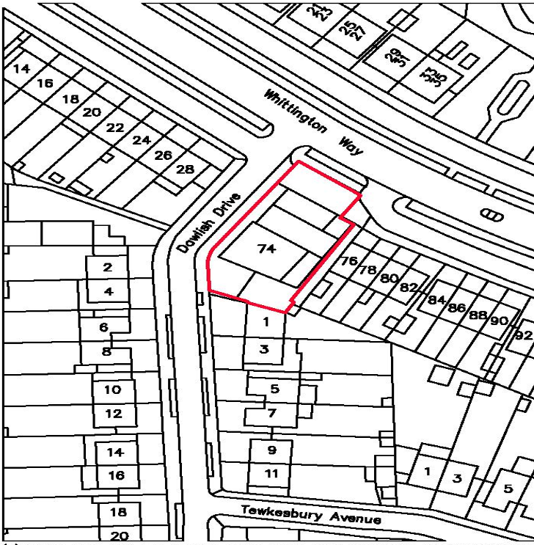
APPENDIX 3: SITE PHOTOGRAPHS

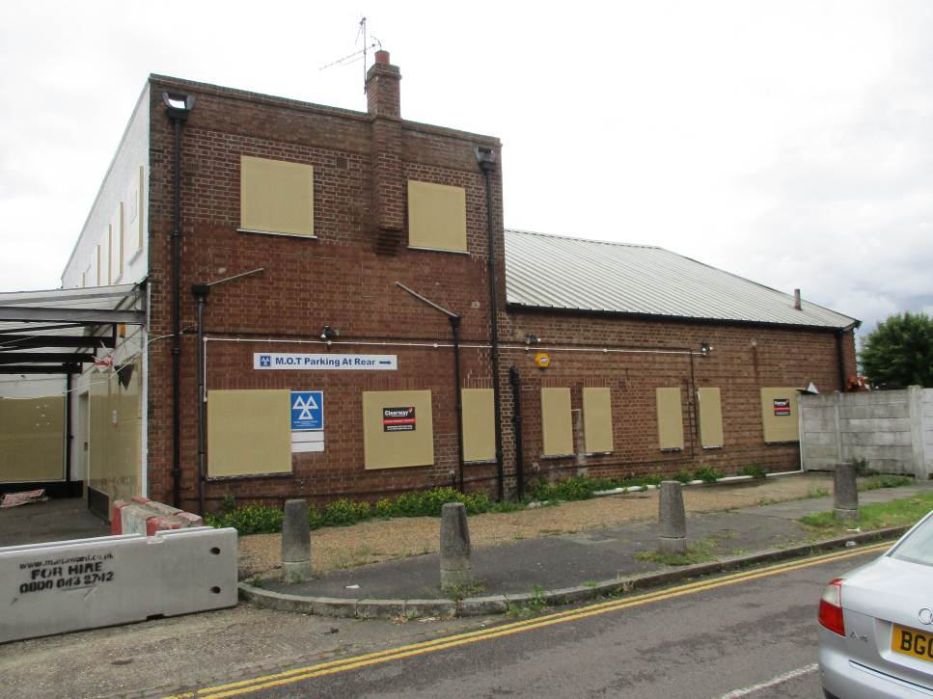
Dawlish Drive elevation

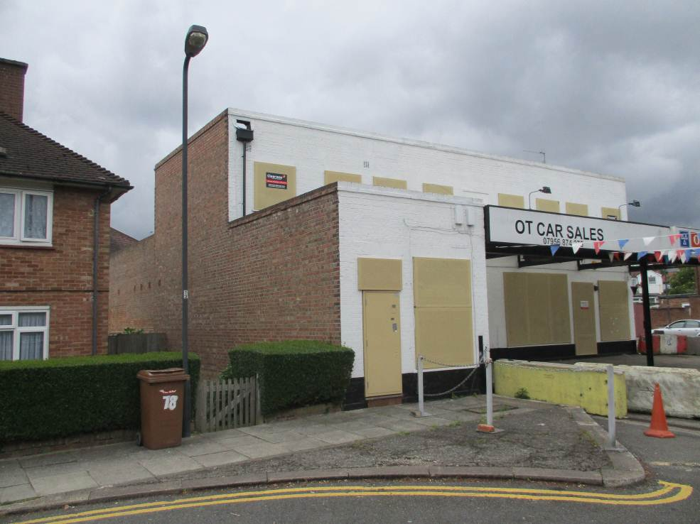
Whittington Way elevation

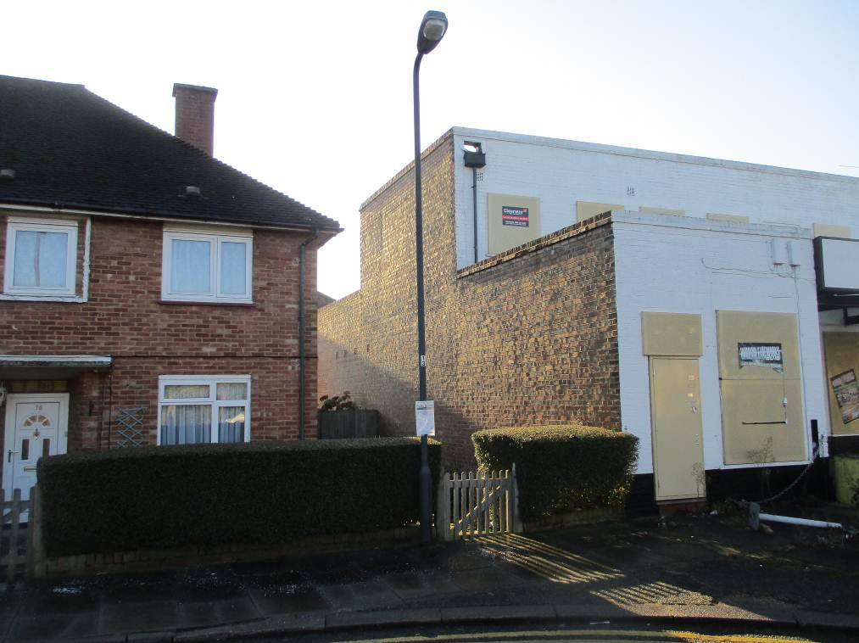
Relationship between site and 76/78 Whittington

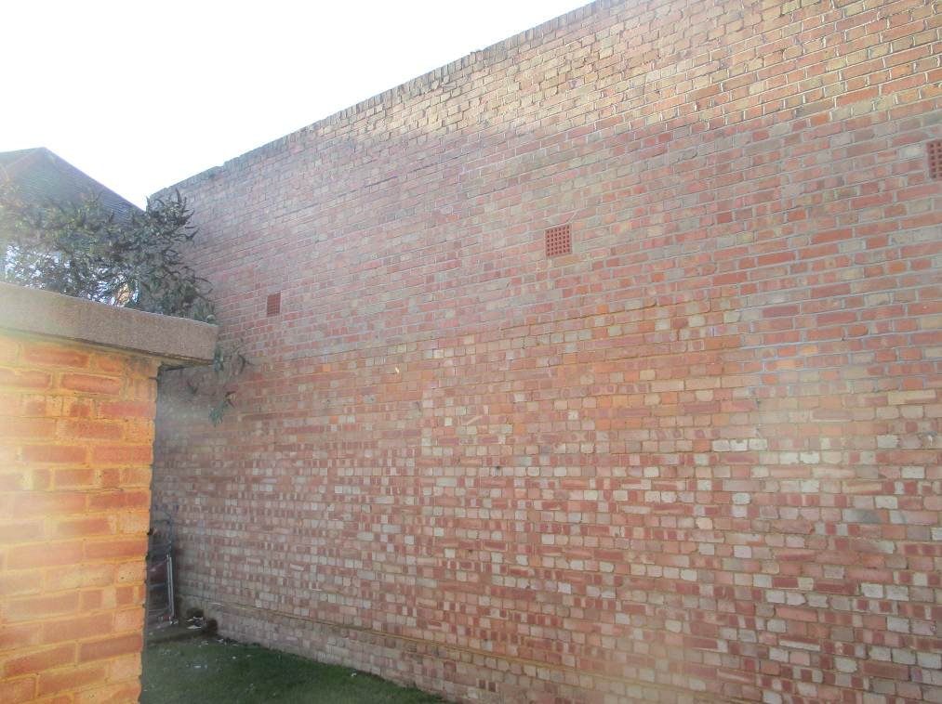
Current view from rear of 76/78

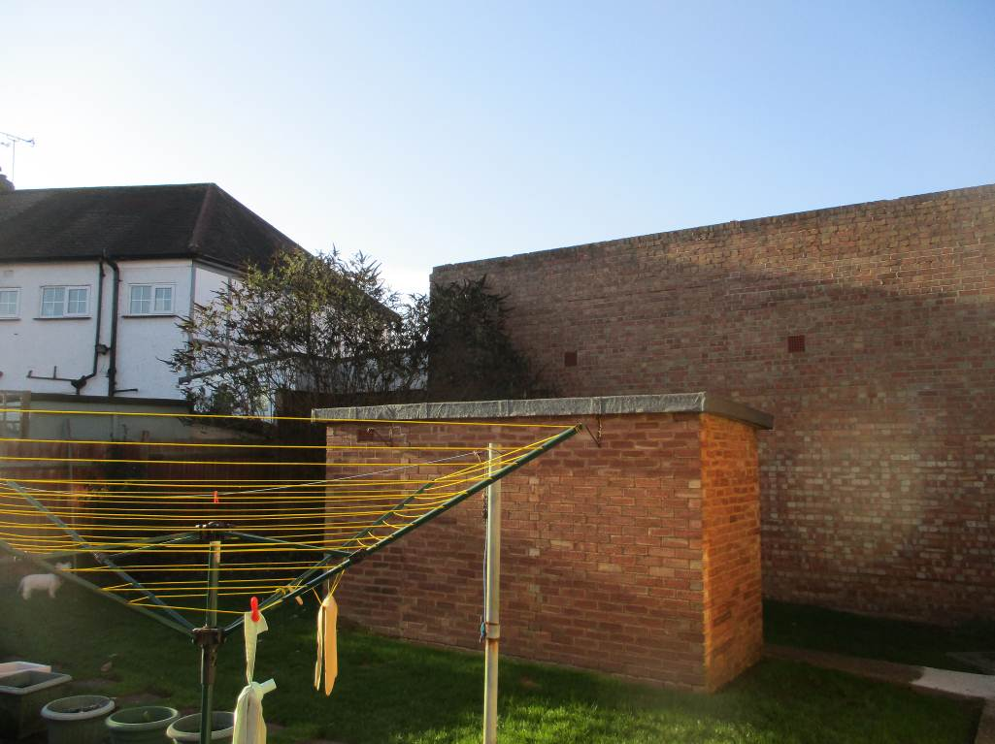
Looking towards rear of site from 76/78 and across to rear of 1 Dawlish.

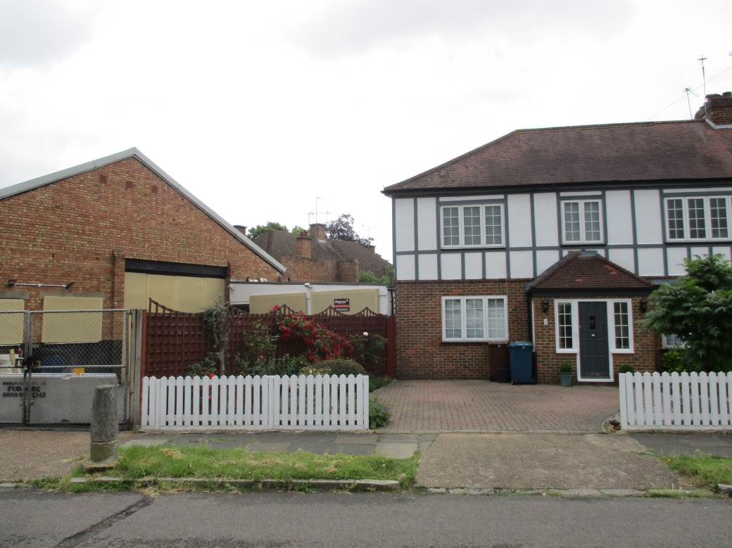
No. 1 Dawlish and application site to the left

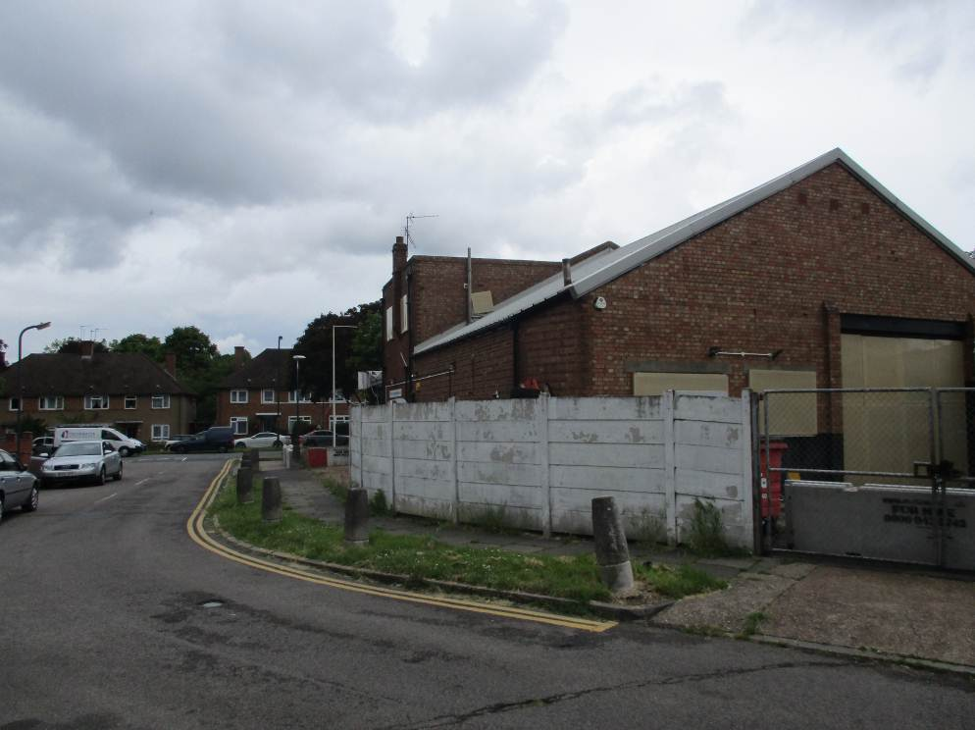
View of rear from Dawlish Drive

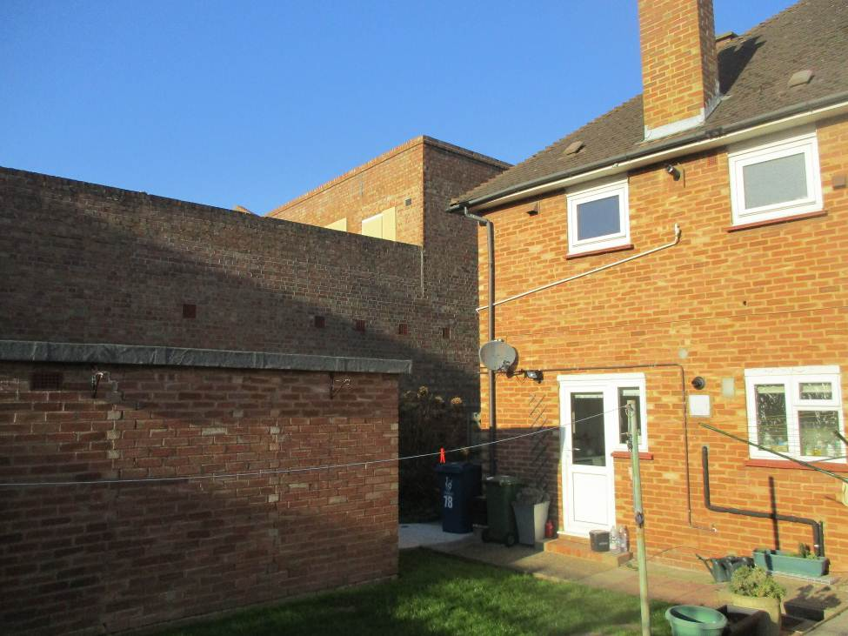
Rear of 76/78 Whittington
APPENDIX 4: PLANS AND ELEVATIONS

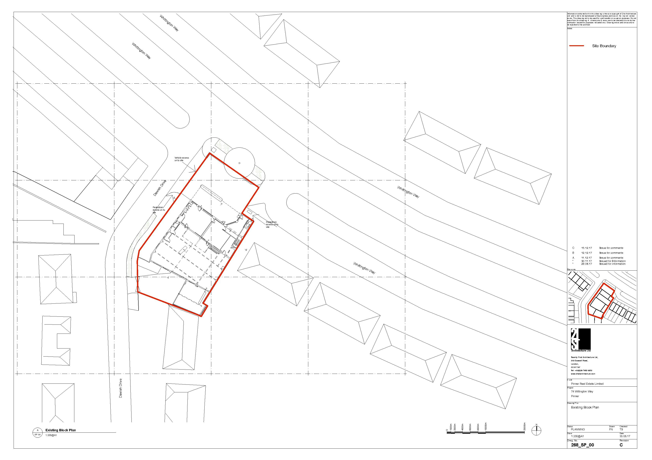
Proposed site plan

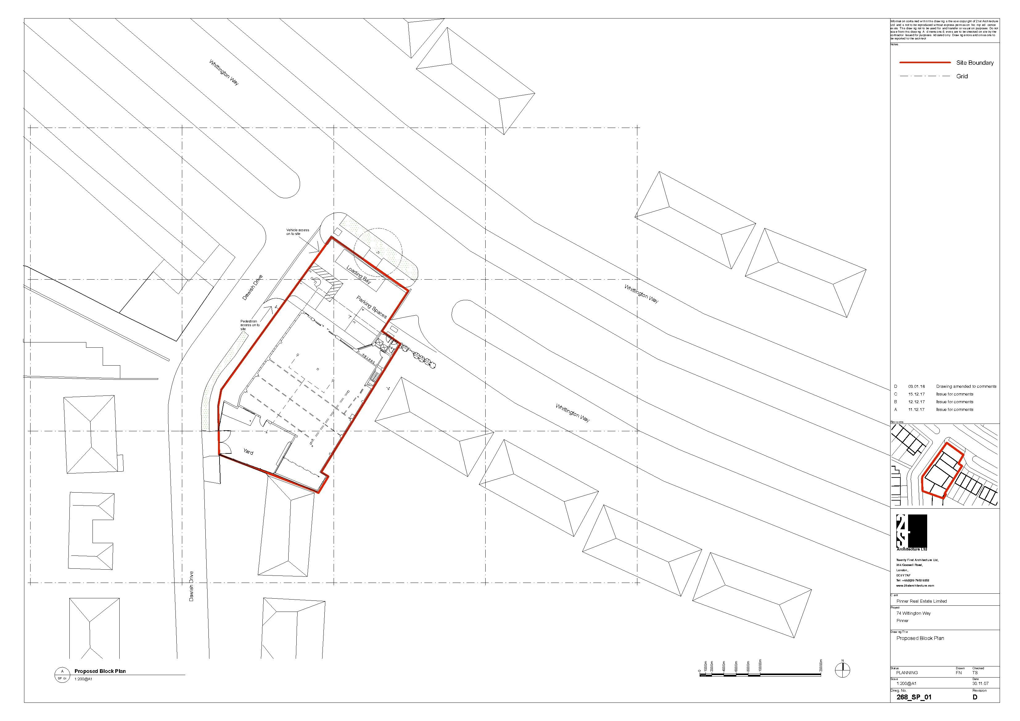

Proposed Ground Floor
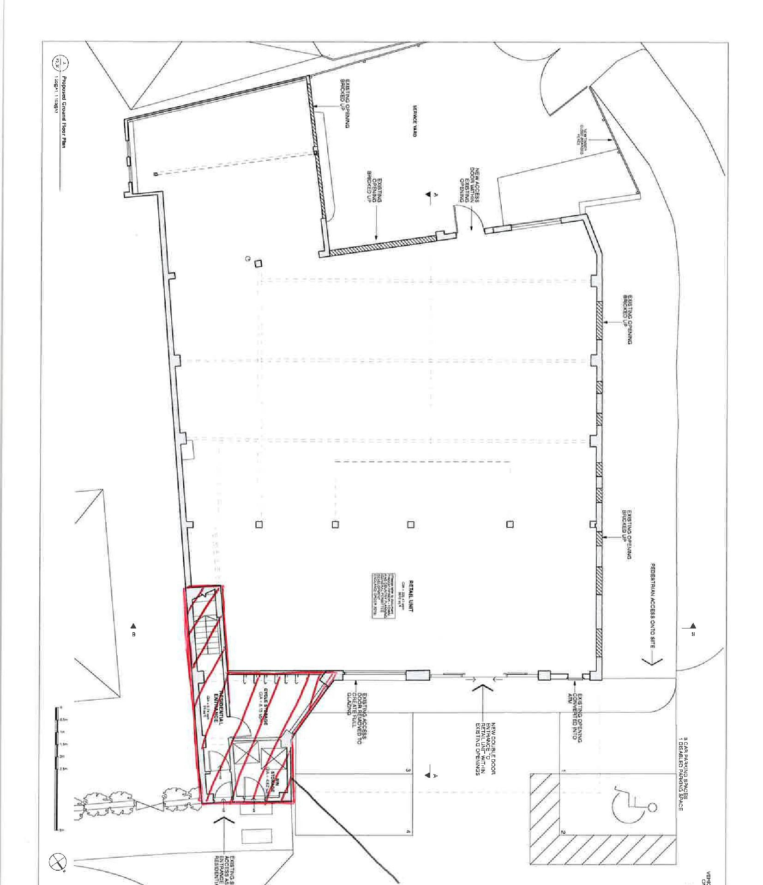

Existing Ground Floor
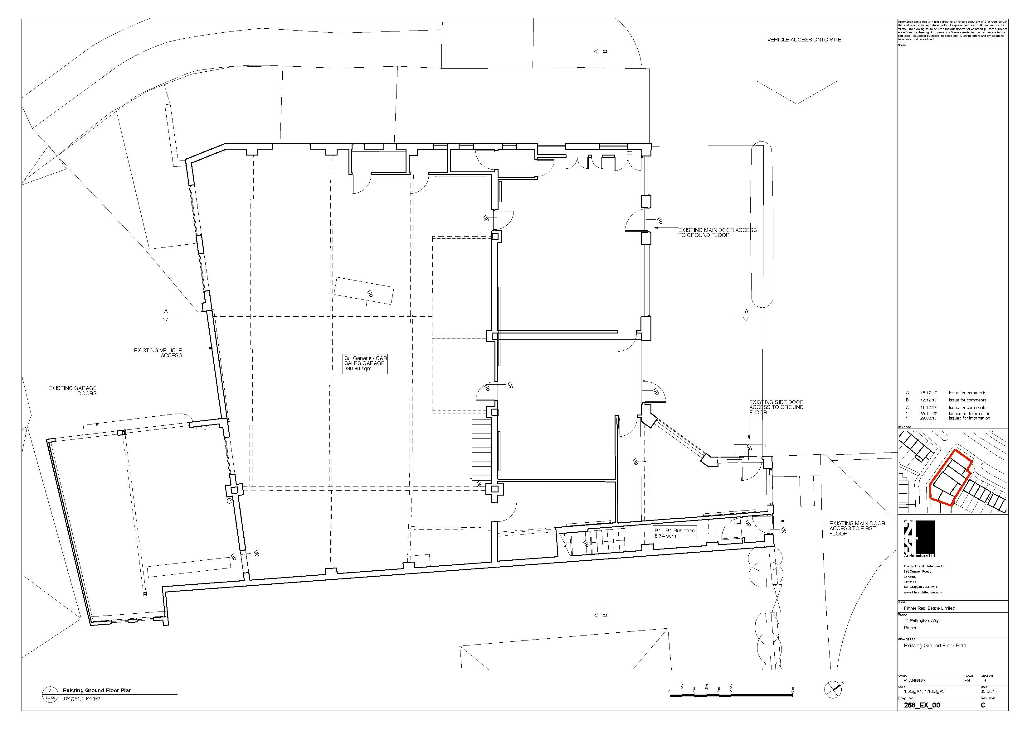
Existing Elevation
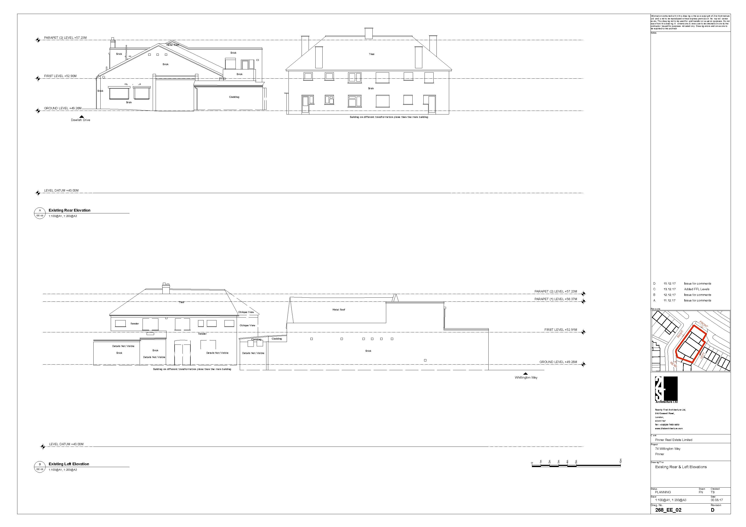

Proposed Elevations
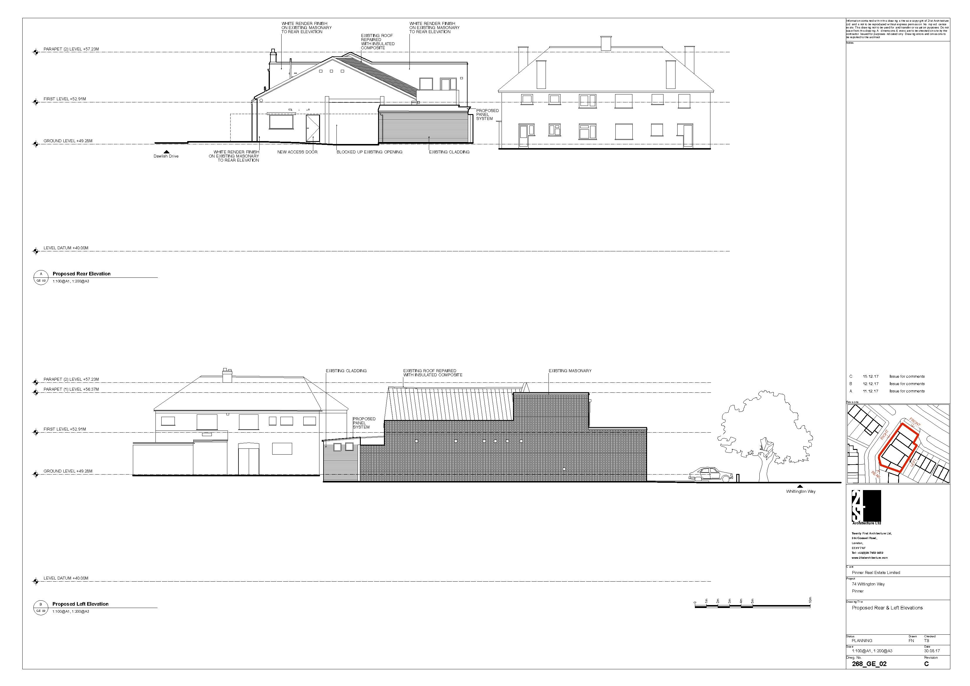

Existing Elevations
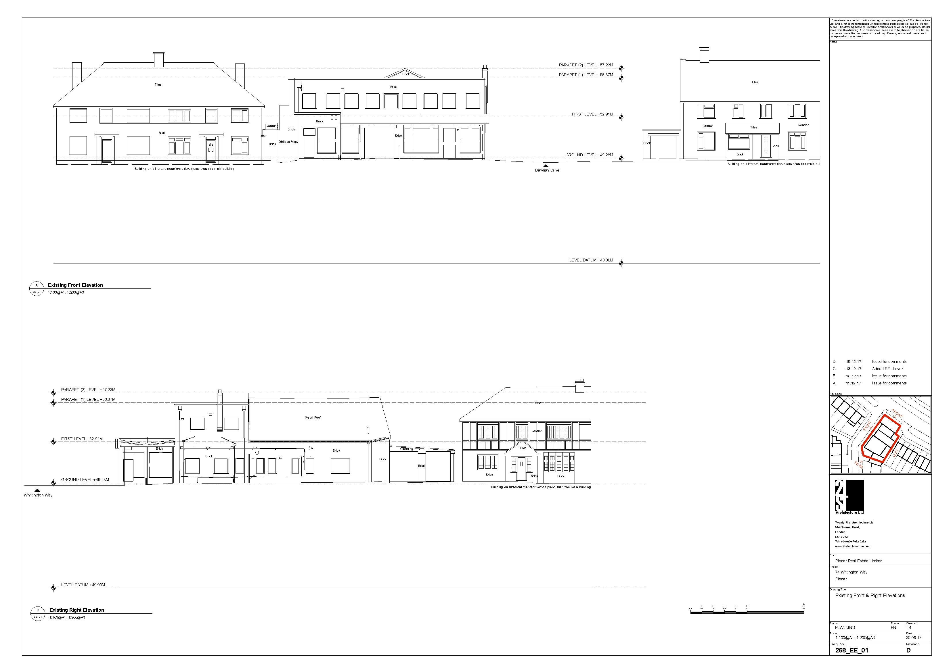

Proposed Elevation
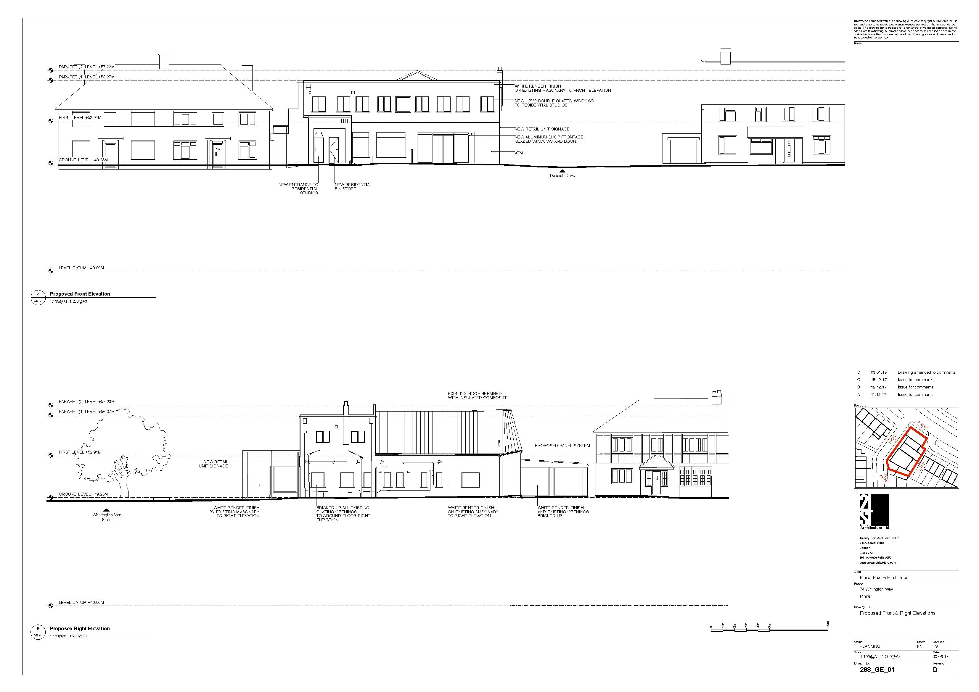
Sections
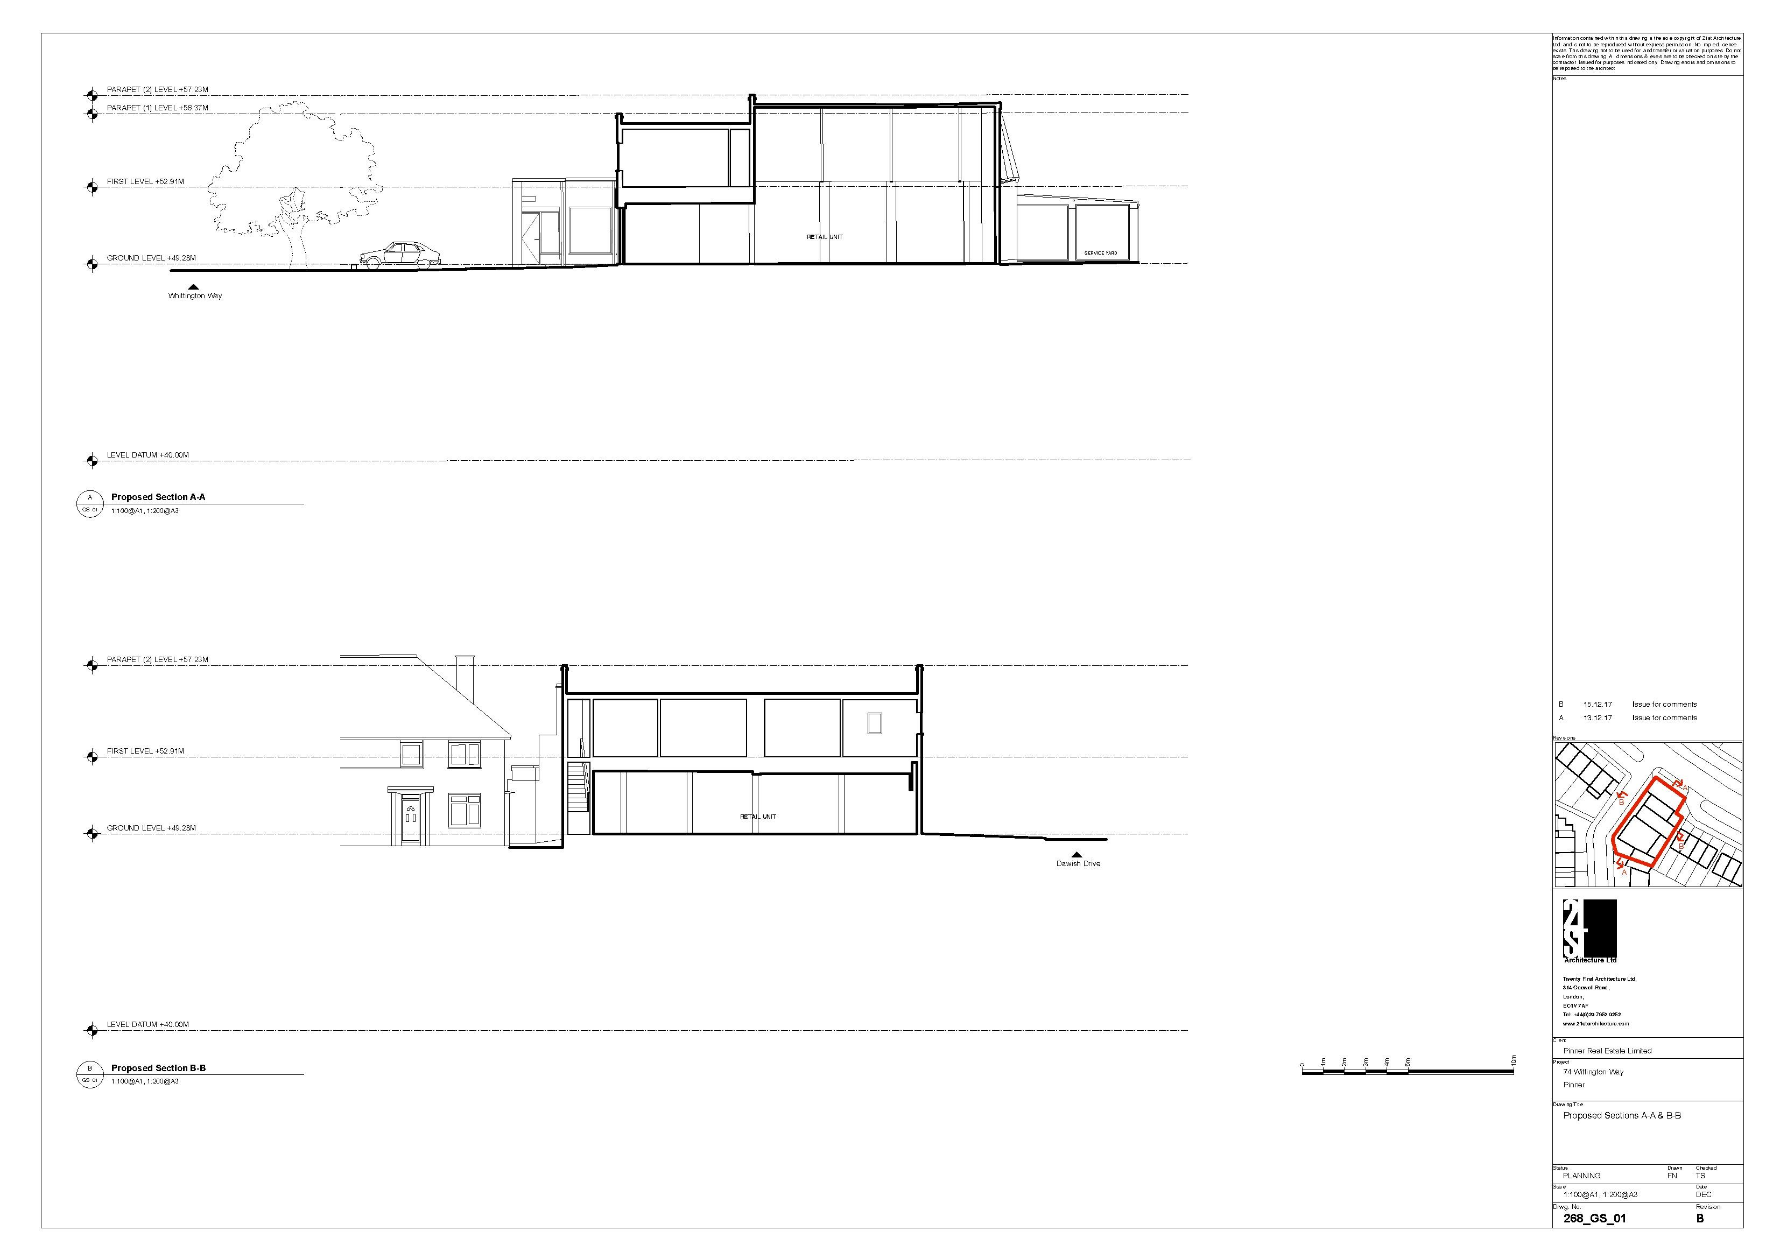

This page has been left intentionally blank

